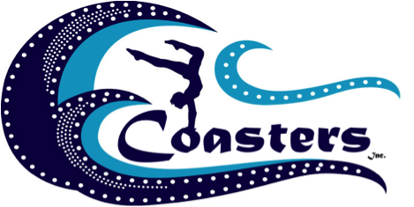

Dear Potential Sponsor,

The Coasters, Inc is a non-profit organization whose purpose is to provide support to competitive gymnasts, dancers, and cheerleaders at Mid-Coast Gymnastics in Selbyville, Delaware.  Our gym has a nineteen-year outstanding reputation.

Our team is comprised of young athletes, each spending many hours per week practicing.  These athletes are high achievers at the gym and at school, organized, self-motivated, and goal oriented as they are constantly setting higher goals for themselves. These goals however, are met at a high cost.  Funds are needed to pay for local, state, regional and national competitions as well as uniforms, etc.  The projected annual competitive cost for the season is approximately $2,000-$5,000 per athlete depending on their level of competition.

Our organization is asking for your help in supporting these talented athletes.  We are searching for corporate sponsors who would be willing to fund our athletes. Your business is being contacted because our families frequently use your services or purchase goods from your store. There are many advantages to being a corporate sponsor of Mid-Coast including;

* Reinvesting your money in the local community,
* Creating awareness of your business through advertisement at our gym, through our website, and on our other social media outlets, and
* Contributing to the community by helping to build self-esteem, confidence, and character in our local youth.

We offer a variety of levels of sponsorship. On the back of this letter, you will find the perks your company will receive at each level. Once you have chosen the level that is right for your company, please complete the sponsorship form and mail it along with your contribution to Coasters, Inc. Be sure to note if you would like your donation to go towards a specific athlete or team (gymnastics, cheer, or dance). If an athlete/ team is not designated, it will be assumed that you would like to split your sponsorship among all of the competitive athletes.

Thank you for your consideration! Every donation is greatly appreciated!  If you would like any additional information or a tour of the gym, please contact us at [coastersmidcoast@gmail.com](mailto:coastersmidcoast@gmail.com). We know you will be impressed with our athletes’ talent!

Thank You!

Coasters Inc.



**SPONSORSHIP LEVELS**

**Copper - $100**

Tax Deduction (consult tax advisor regarding deductibility)

Certificate of Recognition

**Bronze - $250**

Tax deduction (consult tax advisor regarding deductibility)

Framed team picture

2 tickets and VIP seating at Shore Classic Gymnastics Meet

**Silver - $500**

Tax Deduction (consult tax advisor regarding deductibility)

Plaque with team picture

Business logo on banner at Mid-Coast Gymnastics Studio (1 year)

4 tickets and VIP seating at Shore Classic Gymnastics Meet

**Gold - $1000**

Silver perks PLUS…

Business logo on sponsor banner at Shore Classic (1 year)

Link to business on website and other social media accounts (1 year)

**Platinum - $2000**

Gold perks PLUS…

Name/logo on signage at Shore Classic (1 year)

Sponsor acknowledgement announced at Shore Classic

Business card advertisement in end of the year recital program

2 tickets to attend and acknowledgement of sponsorship at annual summer banquet held at Jolly Rogers Waterpark in Ocean City.

**Elite - $5000**

Platinum perks PLUS…

Business name/logo on volunteer t-shirts at Shore Classic

Half page advertisement in end of the year recital program

Company name/logo on sponsored gymnast’s competition bag

4 tickets to attend and acknowledgement of sponsorship at annual summer banquet held at Jolly Rogers Waterpark in Ocean City.

**I would like to sponsor athletes at Mid-Coast!**

Please complete and mail this form along with your contribution to:

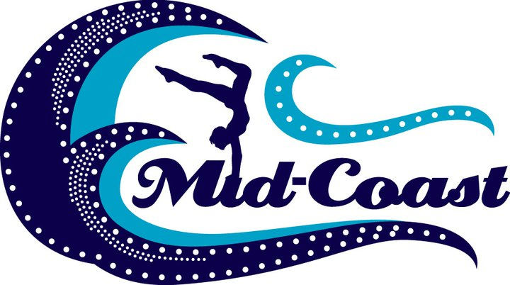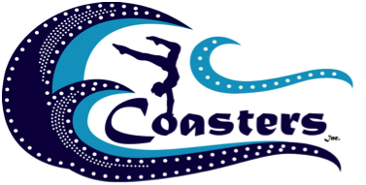

**Coasters, Inc.**

**P.O. Box 50**

**Selbyville, DE 19975-0050**

* All sponsorship checks should be made payable to “Coasters, Inc”
* Sponsorships are valid for one year after funds are received.
* Sponsorship not subject to refund or cancellation.
* Sponsors do not have influence in team matters or operations.

Top of Form

Copper Bronze Silver Gold Platinum Elite



Bottom of Form

($100-$249) ($250-$499) ($500-$999) ($1000-$1999) ($2000-$4999) ($5000+)

**Date Business Name**

|  |  |  |
| --- | --- | --- |
|  |  |  |

**Website**

|  |
| --- |
|  |

**Contact Name (person authorizing sponsorship)**

|  |
| --- |
|  |

**Email Address** **Phone Number**

**Business Address**

|  |
| --- |
|  |

**City** **State Zip**

**Solicited By (athlete’s name & team if known) $$ Amount**

If you are choosing silver, gold, platinum, or elite sponsorship level please email the logo you would like used on the banner and website to coastersmidcoast@gmail.com.

*Thank you for supporting the athletes at Mid-Coast Gymnastics Studio!*